SET 18 – PRODUCT INVENTORY MANAGEMENT
Aim
To analyze product inventory using bar charts, stacked bar charts, and a table in R.
Algorithm
- Create the product inventory dataset.
- Store Product ID, Product Name, Quantity Available, and Price.
- Create a bar chart to visualize the quantity of each product.
- Create a stacked bar chart to compare product quantities.
- Display the inventory data in a table.
- Add suitable labels and titles.
R Program
library(ggplot2)

inventory <- data.frame(
ID=c(1,2,3),
Product=c("Product A","Product B","Product C"),
Quantity=c(250,175,300),
Price=c(20,15,18)
)

ggplot(inventory, aes(Product, Quantity, fill=Product)) +
geom_bar(stat="identity") +
labs(title="Product Inventory Quantity",
x="Product", y="Quantity Available")

ggplot(inventory, aes(Product, Quantity, fill=Product)) +
geom_bar(stat="identity", position="stack") +
labs(title="Inventory by Product",
x="Product", y="Quantity")

print(inventory)
OUTPUT:
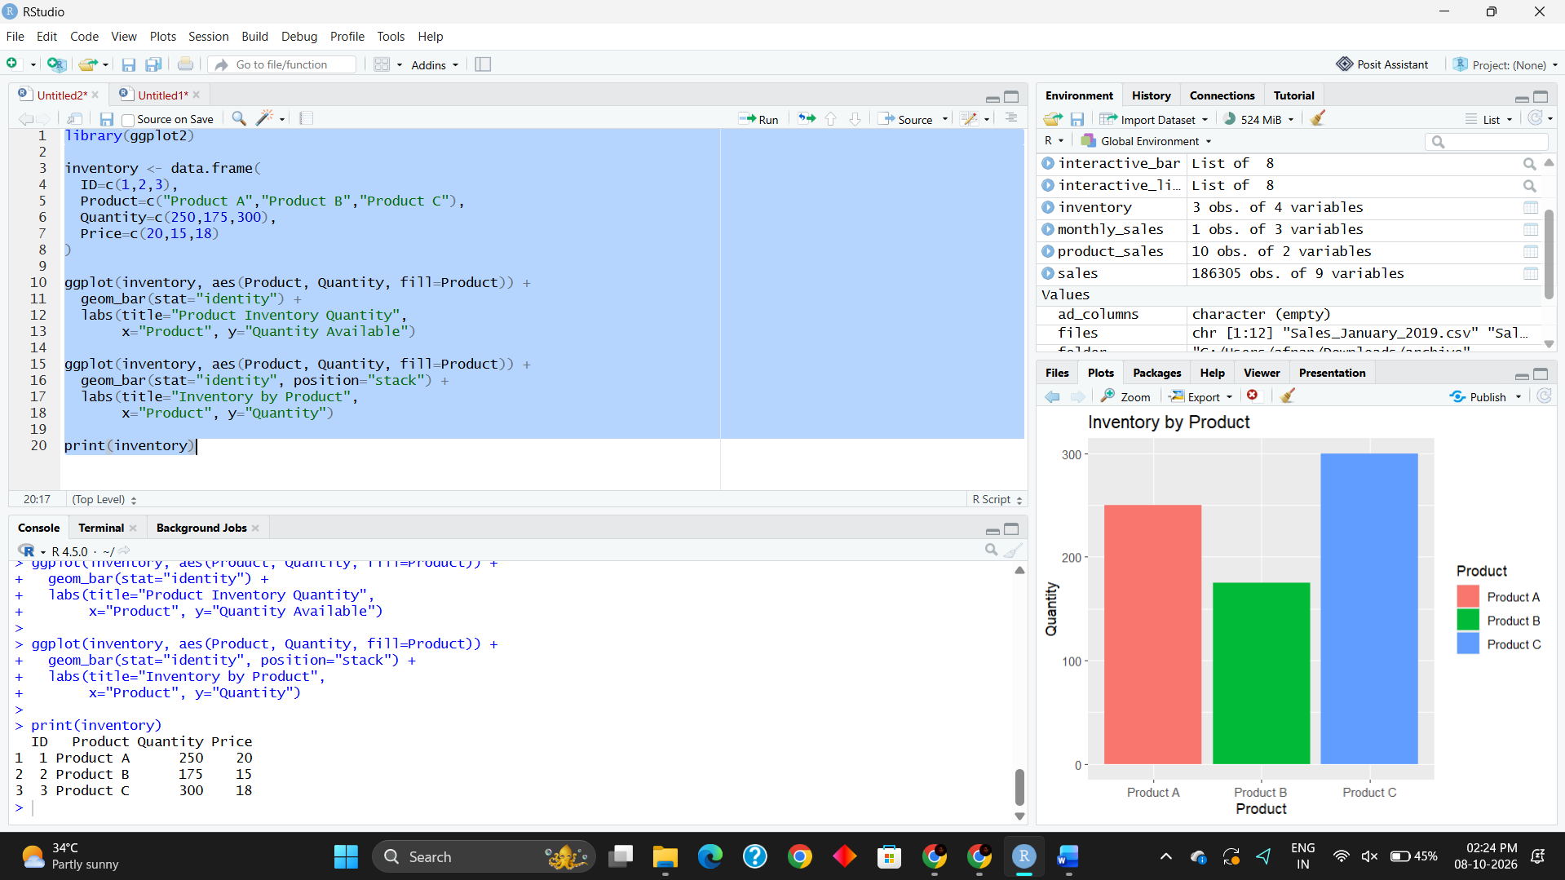
Result
The bar chart successfully displays the quantity available for each product. The stacked bar chart represents the inventory quantities across different products, and the table displays the complete inventory information.

